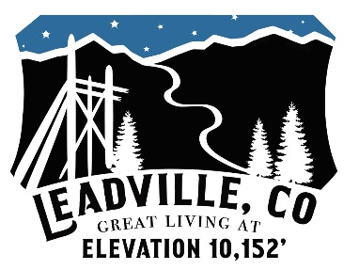

POLICE OFFICER
Leadville, Colorado, sits at 10,152 feet above sea level, the highest incorporated city in the heart of the Rocky Mountains. Leadville offers small town living with the bonus of having a rich mining history and a year-round event calendar. Surrounded by national forests, outdoor enthusiasts enjoy biking, climbing, fishing, running, skiing, hunting, and more. The City of Leadville has immediate openings in their Police Department. The Department is currently seeking applications for the position of Police Officer. The ideal candidate will have a degree in Administration of Justice or a related field (preferred). Must be Colorado Post Certified or eligible for provisional certification. The successful candidate will be subject to an intense background investigation as well as psychological and physical examinations. Salary commiserate with experience. To apply please submit an application, cover letter, and resume to the Leadville Police Department / 800 Harrison Ave. / Leadville, CO 80461 / or, by e-mail to lpdadmin@leadville-co.gov. Applications may be obtained at the Department or on the city website at www.colorado.gov/leadville.

