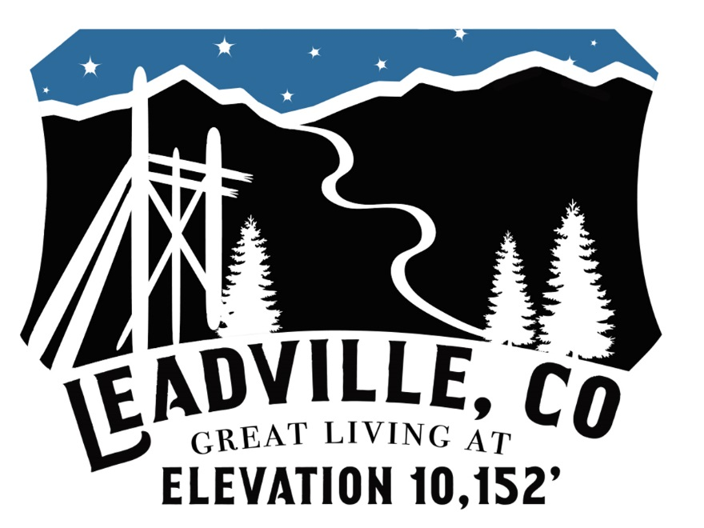
CITY OF LEADVILLE
Excavation Permit Application

NO DIGGING OCTOBER 1 – MAY 1 WITHOUT PRIOR APPROVAL FROM THE CITY
nnnnnnnnnnnnnnn
Applicant Name: Phone: __
Applicant Address: _________________________________________ _ Date of Application:________________________
Public Property Affected by Project (name or describe rights-of-way and other public property): ______
___________________________________________________________________________________________________
Number of blocks on which project will occur:__________________
Job Start Date: Date of Backfill: Date of Completion: _________________
Job Contact (best contact person on job site): _______________________________________ __________________
Purpose/Reason of Excavation: __
__
Additional Required Documents or Information:
☐ Drawing(s) or plan(s) showing location, width, length and depth of all proposed excavations
☐ Itemized list of total estimated cost of restoring public property after completion of project
☐ Copies of any required state, county or other permits
☐ List of persons whose utility services or access will be disrupted longer than 1 hour
☐ Permit Fee: $250 per permit (one permit required per block)
☐ Proof of insurance (see Section 12.12.040 of the Leadville Municipal Code)
☐ Surety (see Section 12.12.040 of the Leadville Municipal Code)
☐ Other documentation required by city:_________________________________________________________________

Work Description  (Check all that apply) | Work Type  (Check all that apply) | Traffic Control  (Check all that apply & attach plan) | Cut Info  (Check all that apply)
Install  Repair  Abandon  Boring  Tunneling  Jacking | Water Manhole  Sewer Culvert  Electric Ditch  Gas Storm drain  Telephone Sidewalk  Cable Right of Way  Communications Other | Flaggers  One lane closure  Road closure  Parking restriction change  Special ROW usage  Speed limit reduction  Other | Asphalt  Concrete  Curb & Gutter  Dirt

Asphalt | Concrete | Curb & Gutter
Dimensions (sq ft) | Dimensions (sq ft) | Dimensions (sq ft)
Special instructions: | Special instructions: | Special instructions:

APPLICANT CERTIFICATION
(carefully review and initial each)
______ 1. Applicant has reviewed and understands all requirements applicable to excavations pursuant to the Leadville Municipal Code and any other applicable law. The City of Leadville has no liability or responsibility for noncompliance by any person or business entity of any local, state, or federal law.
______ 2. Before any emergency excavation occurs, Applicant MUST notify the City of Leadville Street Department by calling (719) 486-1166 (daytime hours) or by calling the Lake County Sheriff’s Office at (719)486-1249 (night hours).
______ 3. A copy of your permit must be displayed and available for inspection by the City at the applicable worksite.
______ 4. Unless approved by the City, all excavation work must occur Monday through Friday between 7a.m. and 7p.m. No digging is allowed between October 1 and May 1 without an emergency permit issued by the City.
______ 5. All work done pursuant to a permit issued by the City shall be performed in accordance with all applicable standards and specifications, which include but are not limited to the City of Leadville roadway design standards, Parkville Water Regulations, Leadville Sanitation District Pipeline and Manhole Design regulations, and any applicable construction specifications. It is the responsibility of the applicant to determine and understand which standards apply to the work.
______ 6. Applicant shall hold the city harmless and defend and indemnify the city, its successors, assigns, officers, employees, agents and appointed and elected officials from and against all liability or damage and all claims or demands whatsoever in nature, including applicant’s violation of any applicable laws or regulations, and reimburse the city for all its reasonable expenses, including reasonable attorney fees and costs, as incurred, arising out of any excavation and related activities in the public right-of-way, including but not limited to the actions or omissions of the applicant, its employees, representatives, agents, contractors, related entities, successors and assigns or the securing of and the exercise by the permittee of any rights granted in the permit, including any third-party claims, administrative hearings and litigation, whether or not any act or omission complained of is authorized, allowed or prohibited by this chapter or other applicable law. Applicant shall not be obligated to hold harmless or indemnify the city for claims or demands to the extent that they are due to the negligence or willful and wanton acts of the city or any of its officers, employees or agents.
______ 7. Applicant may be contacted by the City and be required to submit additional information prior to approval of this application. The City will not approve an application that is incomplete or for which it has insufficient information to ensure that Applicant is in compliance with City standards and regulations.
______ 8. Applicant has reviewed and understands the applicable fines set forth in the Leadville Municipal Code for violations of the City’s excavation regulations or other code provisions.
______ 9. A permit issued by the City may be suspended or revoked and a stop work order issued by the City if the City determines that work is being completed in violation of any applicable standard, regulation, ordinance or condition of a permit.
______ 10. A permit issued by the City shall become void if work does not start within 30 days of issuance of a permit. If a permittee needs additional time to commence work, permittee shall request an extension from the City.

APPLICANT SIGNATURE: ________________________________________________ DATE:________________________

FOR OFFICE USE ONLY
Number of Permits Required: ___________ Total Application Fee (# of permits x $250): _______________
Application Fee Paid: Y N Application Fee Receipt No.:_____ ________ Application Approved: Y N
Permits Issued (enter permit numbers for each permit issued for the project):

Application Reviewed and Approved By:
Administrative Assistant: ______________________________
Signature: __________________________________________ Date: ____________________________
Street Supervisor: _________________________________ __
Signature: __________________________________________ Date: ____________________________
Inspection TYPE: | PRECONSTRUCTION | COMPLETED WORK | UTILITY MARKING | WARRANTY
Completed By:
Date:
Notes/Instructions:
NOTE: List additional inspections and conditions on the permit form prior to issuing permit to applicant. Conditions and additional inspections are determined through the application review process (contact city engineering consultant with questions prior to issuing permit) and preconstruction inspection.

Total Surety Amount: __________________ Form of Surety Submitted: ☐ Company (corporate) check
☐ Cashier’s check
Blanket Surety: Y N ☐ Bond
☐ Letter of credit
SURETY RELEASE BY: ________________________ SIGNATURE: _____________________________ DATE: _______________
RELEASED TO | Name: | Notes:
Amount: | Address:

